Health Risk Assessment
Standard Operating Procedure – Completion of OREPs

Table of Contents

1 INTRODUCTION 3
2 PURPOSE 4
3 METHODOLOGY 4
3.1 HOW TO COMPLETE THE OREP CAPTURE FORMS: 4
3.1.1 The Inherent Requirements Section of the OREP: 5
3.1.2 The Hazard Exposure Section of the OREP: 7
3.2 SCORE ALLOCATION GUIDELINES 9
3.3 REFERENCE SECTION: GUIDELINE TABLES FOR THE ALLOCATION OF SCORES 9
4 THE APPENDICES 16
4.1 Appendix 1: Illustration of an OREP, with 1-column Risk Reference. 17
4.2 Appendix 2: Illustration of an OREP, with 3-column Risk Reference. 18

Index of Figures

Figure 1: The relationship between the OREP and Risk Assesment. 3
Figure 2: Diagrammatic representation of the OREP. 4
Figure 5: Sample blank OREPs, indicating two possible variations of data collection. 9

Index of Tables

Table 1: Table of Guidelines for allocation of “Capability Requirement” Standards: 10
Table 2: Summary Guideline for the allocation of scores. 14
Table 3: Scoring “Exposure” Intensity: Guidelines for Physical & Environmental Hazards 15

INTRODUCTION
Occupational Health is a preventive discipline, dedicated to reducing the likelihood of adverse events leading to injuries, illness or material losses. Central to this is the science of Risk Assessment. This is at the core of Occupational Health, from which every subsequent action is derived.
Occupational Health Risk Assessment is the systematic examination of activities and processes in the workplace, to determine the probability of harmful events, and the extent of the potential damage. This evaluation comprises a careful evaluation of the level of probability that the adverse event may occur, and the consequences of these events.
- The probability is a function of the estimated likelihood that the incident may occur, or of the degree of exposure of the target groups.
- These consequences quantify the degree and severity of harmfulness of the hazards.
Hence:
RISK = CONSEQUENCE X PROBABILITY

The Occupational Risk and Exposure Profile (OREP) is the formal documentation of the results of a Risk Assessment, for a single occupational exposure group (i.e. a job category). It comprises two main groups of data, all on one page:
- Data that defines the inherent capability requirements of the occupation are listed. Failure to meet these requirements increases the company’s liability by increasing the risk of an accident.
- Data pertaining to the hazardous exposures unique to each occupational category

As this document forms a key part of Risk Assessment, it is the cornerstone of future action, providing key information for subsequent risk reduction strategies, Education and Training, Occupational Safety, Occupational Hygiene, Occupational Medicine and Recruitment Policy.
Figure 1: The relationship between the OREP and Risk Assessment.
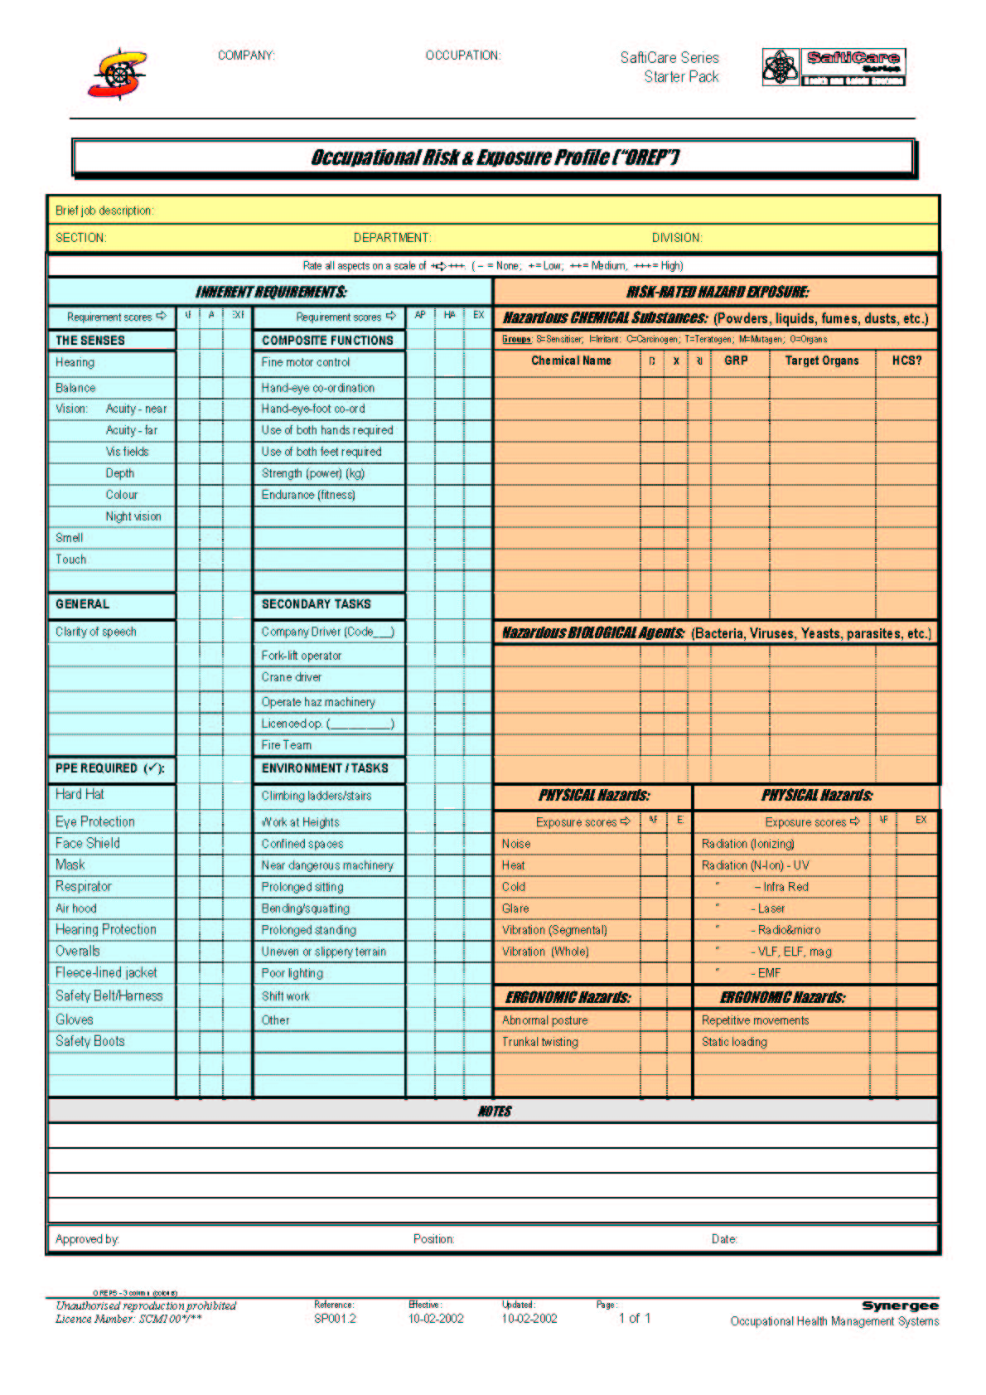
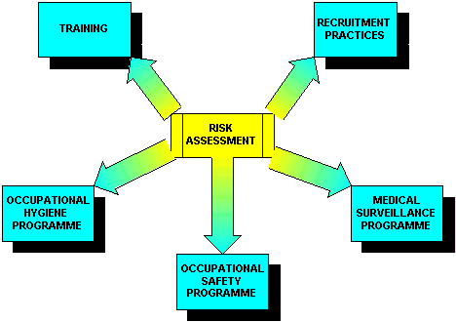
THE OREP

Figure 2: Diagrammatic representation of the OREP. | The information directs the components of the Occupational Health Programme by:  - Ensuring that hazard exposure information is available to all parties (“Risk Assessment beneficiaries”)  - Establishing minimum health requirements in advance.  - The information directs any training needs, as prescribed by the Hazardous Chemicals Substances regulations.  - The information determines placement requirements for the various occupations, improving the effectiveness of the Human Resources personnel. This provides protection from the Labour Relations and Employee Equity Acts, which require rational and defendable approaches to employment/placement strategies AND incapacity management.  - Presenting the required data for all the beneficiaries of the Risk assessment in a manner that enables rapid implementation

PURPOSE
The Standard Operating Procedure provides detailed guidance regarding a workplace-based Health Risk Assessment (HRA).

METHODOLOGY

HOW TO COMPLETE THE OREP CAPTURE FORMS:
The process of completing the OREPs can be accomplished in any way that is appropriate to the team involved.
One way is to use the OREP documents directly as input sheets to gather information by Job Category, as long as the Job Category comprises people with identical risk profiles (also known as “Homogenous Exposure Groups”, or “HEG’s”). This process can be by interviews, completion of the sheets by the employees themselves (or by their supervisors). Input from Safety Reps is useful.
Another way is to draw on the facility Health Risk Assessments, and create software that is able to convert risk information that is organised by location, to risk information that is organised by occupation.

The Inherent Requirements Section of the OREP:
In this section, there are three types of data required. This data is recorded as numerical values, or as simple asterisks, or plus signs in the columns indicated, “CAP”, “CON” and “PROB”. These abbreviations have the following meanings:

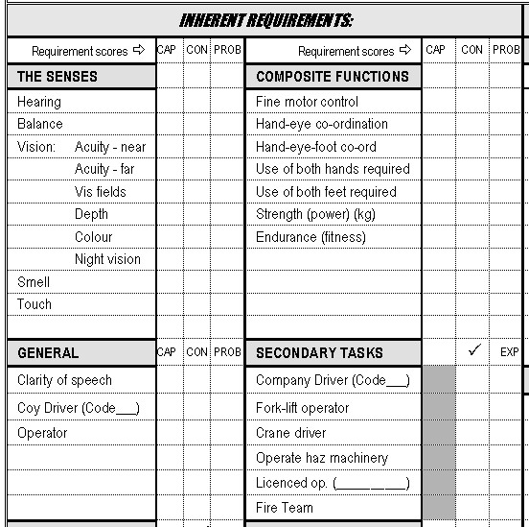 | - “CAP” refers to the “Capability Requirement” Score, which refers to the value, out of 0-4, which best matches the requirement standard, as taken from the pre-constructed tables provided.  - “CON” refers to the “Consequence” score, which refers to the value, out of 0-5, which reflects the potential damage that could take place, should something go wrong as a result of operator error, should the employee’s capability not meet the requirements of the occupation.  - “PROB” refers to the “Probability” Score, which refers to the value, out of 0-5, which reflects the “likelihood” of an incident, and the degree of time spent (“exposure”), as a proportion of the entire job description, in the tasks that require the above degree of capability.

Note:
The Capability Requirement Scores provide the fitness standards for the relevant OREP elements, and are taken from the Capability Requirement Table, which are provided later in this document.
The “Consequence” Scores and the “Probability” Scores provide the risk information for the relevant OREP elements, and are also taken from standardised tables. These are explained fully on the Risk Assessment Procedure Guideline.
In keeping with the standard approach to Risk Assessment, the “Risk” factor is derived by the multiplication of the “Consequence” score and the “Probability” score.
“Operational Requirements”:
The Capability Requirements are also determined by operational requirements. This may not have any bearing on the Risks associated with the occupation. Hence a task may have a high Capability Requirement score, but a low Risk Score. This indicates that the high capability is required for operational reasons, rather than for risk reasons.

Important Points to Note:
Some companies prefer to simply the process of capturing the Capability Requirements section by limiting the data entry to ONLY THE CAPABILITY REQUIREMENTS SCORE. These companies will use the OREP sheets with only 1 column in the Capability Requirements Section of the OREP.
However, there is a real benefit in going the extra mile. The reason is these are the only risk indicators associated with the “critical and liable tasks” of the company. Providing risk scores for just the “Effect Risks” will miss a large group of activities that constitute a substantial burden of risk for the company.
An evaluation of the “Capability requirements” alone does NOT measure the risks associated with these activities. These merely set the standards that need to be met by the employees who occupy these positions.
The value of the allocation of Consequences and Probability to all the Capability Requirements is that future decisions regarding worker fitness are simplified. In this way, the degree of latitude for medical fitness for the applicable occupation becomes more transparent.
Example:
An occupation may have a high Capability Requirement, but the Probability score may be low (only occasionally is required to conduct activities for which there are high capability requirements). Hence, it is possible that with some minor job alterations, the employee may still be able to continue working in that occupation. This would not be possible should the Probability score also have been high.
Note:
In the vast majority of cases, for the purposes of fitness adjudication, the medical examiner will refer primarily to the Capability Requirement standard and only refer to the Probability scores and Consequence scores by exception. This is because the capability requirement standard is the primary determinant of the WASP standards.
An alternative approach:
Some companies may decide to allocate a single combined risk score that represents a composite assessment of the potential harm that may be caused by operator error, after consideration of all the requirements. In this circumstance, the Capability Requirements component of the OREPs will require only the completion of the Capabilities scores, and a single, separate Capability Risk factor will be estimated for that occupation.

More on Capabilities Scores
These fitness standards may be legal, industry-based, or simply set by the company itself. Remember that not many standards are set in law, and that the company may (indeed, it should), set these standards itself, in accordance with its own unique circumstances. The prerequisite is that the standards should be scientifically defendable, and should be introduced in a participative manner, as they often impact directly on conditions of employment.
The challenge with setting these standards is that they are very complex, and often require multiple factors that require consideration, including:
- “positive” (“inclusion”) factors, which refer to the inherent capability requirements of the occupation.
- “negative” (“exclusion”) factors, which refer to the medical conditions which should NOT be present for the occupation to be carried out safely.
Point to Note:
The “positive” factors are listed in “Occupational Risk and Exposure Index” (“OREP”) documents (in the inherent requirements section). They can be directly linked to an entity that is medically measurable, such as visual acuity and hearing, etc.
The “negative” factors are recorded in the “Worker-Allocated Surveillance Programmes” (“WASPs”). These are listed in the document, “Guidelines to the Development of WASPs”. A further good example of this is the list of exclusions in the “Driver-Operator Health Policy”.
These positive and negative factors make up the Medical Standards of Fitness that are central the Medical Surveillance programmes that follow Health Risk Assessment.

These medical standards of fitness may be “absolute” or “relative”.
Absolute exclusions: This includes the exclusions prescribed by law such as many of the exclusions prescribed for occupational drivers. These are obligatory exclusions for which the medical examiner’s professional judgement plays a minor or no role regarding fitness to perform the task.
Relative exclusions: this refers to those medical conditions that require professional judgement regarding fitness for the task. These are discussed in the procedure document for the development of WASPs. They include a wide variety of medical disorders, which either:
increase the employee’s vulnerability to the hazard exposure (increase “Effect Risk”)
or, by failing to meet the fitness standard, produce a situation of “Capability Risk”.

The Hazard Exposure Section of the OREP:
In this section, there are two types of data required. As for the Inherent Requirements Section, this data is recorded as numerical values, or as simple asterisks, or plus signs in the columns indicated. These are headed, “CONS”(or “TOX”) and “PROB”. The extra column headed “RISK” simply provides a location to place the resulting “RISK INDEX”, which is the result of multiplying the CONS(or TOX) score by the PROB score. These abbreviations have the following meanings:

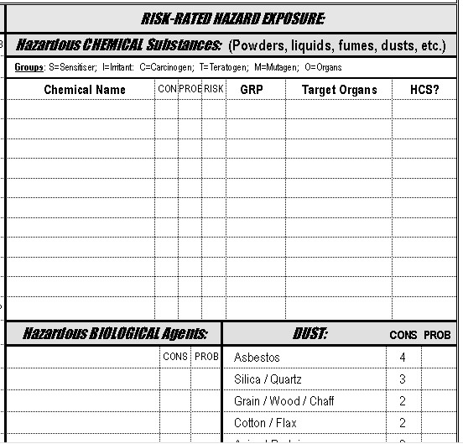 | - CONS” refers to the “Consequence” (or “Toxicity”) score, which refers to the value, out of 0-5, which reflects the potential health impacts that could take place, should sufficient exposure take place, given the nature of the occupation.  - “PROB” refers to the “Probability” Score, which refers to the value, out of 0-5, which reflects the degree of exposure that can be expected, in time and degree of intensity.  - “RISK” refers to the “Risk Index”, which is the result of multiplying the “Consequence” score by the “Probability” score, and has a maximum value of 25.

Note:
The “Consequence” Scores and the “Probability” Scores are derived from the standardised tables.
In keeping with the standard approach to Risk Assessment, the “Risk” factors are derived by the multiplication of the “Consequence” Scores and the “Probability” Scores”.
There is no equivalent of the “Capability Requirement” score (see “Capability Risk” above) in the evaluation of Effect Risk.

In summary, therefore, the data is collected into the OREPs as follows: (also see the appendices).

Figure 3: Sample blank OREPs, indicating two possible variations of data collection.
The 1-column OREP  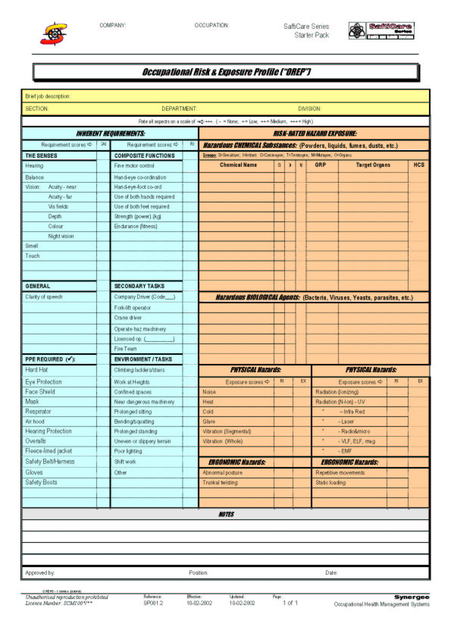  The 1-column OREP only records the “Capability Requirement Standards” in the Inherent Requirements section. | The 3-column OREP  The 3-column OREP records the “Capability Requirement Standards”, the “Consequences Scores”, and the “Probability Scores” in the Inherent Requirements section.

Once the OREPs are completed, these should be reviewed and standardised (by the professionals in the Safety Team). This is an important phase, which sets an even standard for the scores, across the company.

SCORE ALLOCATION GUIDELINES
The theory behind the allocation of the RISK SCORES is discussed in detail in the Health Risk Assessment Procedure Guideline. This shall not be repeated in this document.

REFERENCE SECTION: GUIDELINE TABLES FOR THE ALLOCATION OF SCORES

Table 1: Table of Guidelines for allocation of “Capability Requirement” Standards:
CAPABILITY |  score |  score |  score |  score
Hearing | Can hear normal spoken speech  Eg; customer services personnel | Should be able to hear normal spoken speech and electronic signals in the presence of background noise.  Eg. Forklift driver, machine operator | Can hear subtle sounds such as unusual engine noises.  Eg; Engineering maintenance | Individual requires good hearing at high and low frequencies.  Eg; critical occupations responding to auditory signals.
Balance | Able to maintain balance on EVEN surfaces in the presence of dangerous machines.  Eg: Operators in ergonomically unsound environments. | Able to maintain balance on UNEVEN or unstable surfaces in the presence of dangerous machines.  Eg: Artisans, forestry workers, miners. | Able to maintain balance whilst climbing and working on ladders.  Eg: Painters, renovators, builders, electrical pylon workers. | Able to maintain balance on narrow structures at great heights.  Eg: Riggers and certain construction workers.
Visual Acuity (near) | Must be able to identify large objects up close  Eg. Tools and major components | Must be able to read normal sized text.  Corrected vision acceptable.  Eg Secretary, or artisan handling small components. | Must be able to read small sized text, and correctly identify small objects, such as the elements of circuit boards.  Corrected vision acceptable.  Eg. Electronics technicians. | Must be able to read small sized text, dials and instrument panels.  Corrected vision NOT acceptable.  Eg. Pilots
Visual Acuity (far) | Must be able to identify large objects at a distance.  Corrected vision acceptable.  Eg; Out door worker | Must be able to read traffic signs at a distance.  Corrected vision acceptable.  Eg; Light delivery van driver, forklift operator. | Must be able to identify small objects at a distance.  Corrected vision acceptable.  E.g. Bulk truck driver, crane operator. | Must have perfect vision.  Corrected vision NOT acceptable.  Eg; Commercial & Fighter pilots
Visual fields & Binocular Vision | Normal lateral vision (70 degrees), in at least one eye.  Loss of vision in one eye acceptable.  Eg: Category A & B drivers, casual driving of bikes & quad bikes. |  | Normal lateral vision (70 degrees), without blind spots, for both eyes.  E.g.: Forklift operators, Log loaders, workers in proximity of unguarded dangerous machines and drivers in Category C and above.
Depth & Binocular Vision | Three-dimensional perception required. Tasks are generally non-hazardous.  Eg:, Lab workers. | Three-dimensional perception required, with allowable margins for error - in moderately hazardous tasks.  Eg:. Electronics technicians. | Three-dimensional vision required, with little margin for error - in hazardous tasks.  Eg: Forklift driver, Electricians. | Three dimensional vision required, with no margins for error - in very hazardous tasks  Eg. Bomb diffusers, Eye surgeon.
Colour vision | Must be able to distinguish primary colours.  Eg; electrician – red, green, blue, brown |  | Must identify subtle colour differences, such as in chemical titrations.  Eg; analytical chemists. | Must identify subtle hues and shades.  Eg; textiles & dying industry.
Night vision | Performance of non- hazardous, visually dependent tasks in poor lightning conditions.  Eg. Dark room work | Performance of moderately hazardous, visually dependent tasks in poor lightning conditions.  E.g. Night patrol security workers. | Performance of hazardous, visually dependent tasks in poor lightning conditions.  E.g. Occupational night driving (Standby/ log loader/ bell driver)
Smell | Basic smell perception required for core smell elements.  Ability to smell may be a safety requirement.  Eg: Emergency rescue services | Moderately developed smell perception required for aroma variances.  Eg: Analytical chemists. | Well-developed smell perception required for subtle aroma variances.  Eg: Cooks, wine tasters.
Touch | Basic touch perception required for core touch elements.  Ability to feel may be a safety requirement (prevent burns).  Eg: Furnace workers, cold storage workers. | Discriminatory touch perception required for hands to tell certain materials apart.  Eg: | Well-developed touch perception required for subtle variances.  Eg: Quality control workers.
Clarity of speech | Preferable  Eg. Office workers | Advisable  Eg. Supervisory staff | Essential  Eg: Telephonist, Public relation officials | Critical communications  Eg: customer services centres, emergency call centres
Company Driver | Motor Cycles, Light Motor Vehicles on site only. | Motor Cycles, Light Motor Vehicles on public roads. Metro train drivers. | Heavy equipment, but on property only. (Excavation) | Hazchem or bulk truck driver or other very large vehicles on the open roads. Aircraft Pilots. Ship pilots. Long distance train drivers.
Operator | Moderately hazardous equipment, such as packing, stamping, milling. | Hazardous equipment, involving grinding and cutting. | Very hazardous equipment, such as lathes. | Extremely hazardous equipment, with many moving parts and limited protection for the user.
Fine Motor Control | Able to perform works requiring non-precision tasks on large objects.  Eg: Waitress/Butler, Packers. | Performing precision work on small objects.  Eg: Instrument technicians, needlework. | Performing precision work on very small objects (microscopic).  Eg: Circuit board workers, jewellery manufacturers and watchmakers. | Performing precision work on microscopic objects.  Eg: Microsurgery, microscope lab work.
Hand-eye co-ordination | Able to perform tasks that require co-ordinated action of hands, in accordance with visual input.  E.g.: Operation of certain machines (levers), Waitress/Butler | Able to perform tasks that require complex co-ordinated action of hands, in accordance with visual input.  Eg: Packers on a production line. | Able to perform tasks that require complex co-ordinated action of hands, in accordance with complex visual input.  Eg: Packers on a production line, where the objects are moving on various racks. | Eg:
Hand-eye-foot co-ordination | Able to perform tasks that require singular use of the hand versus footing.  E.g.: Guillotine and press operators, dicta typing. | Able to perform tasks that require simultaneous use of the hand and foot.  Eg: Driving | Able to perform tasks that require multiple variations with integrated intensity of movement between both hands and feet.  Eg: Special equipment operators (cranes, Log loaders, etc.), musicians.
Use of both hands | Advisable  Eg: Typist | Recommended  Eg: Labourers. | Required  E.g.: Commercial drivers. | Essential  Eg: Special equipment operators (cranes, loaders, etc.)
Use of both feet | Advisable  Eg: Supervisory staff | Recommended  Eg: Ergonomic factors, such as work where footing is very uneven. | Required  E.g.: Labourers (heavy manual labour), artisans | Essential  Eg: Special equipment operators (cranes, bell loaders, etc.)
Strength | Average – will cope with 15 - 25kg.  Eg: Engineering maintenance | Stronger than average – will cope with up to 50kg.  Eg: Gen. Labourers. | High strength required – over 50kg.  Eg: Construction. | High strength required – over 50kg, even under arduous circumstances.  Eg: Underground mining
Endurance | Intermittent heavy work, each session typically less than 2 hours.  Eg: Engineering maintenance | Periodic heavy work, each session typically 2-4 hours.  Eg: Gen. Labourers. | Constant heavy work, each session typically4-8hours.  Eg: Construction. | Constant heavy work, even under arduous circumstances, sessions typically 4-8hours or more.  Eg: Underground mining
Climbing ladders/stairs | Low ladders, wide secure footing. | Narrow staircases, steep inclines. | Tall, narrow ladders, non-secure footing. | Very tall ladders, such as up smoke stacks, masts, etc.
Work at heights | Low ladders, mezzanines, tops of vehicles, etc. | From 2 to 4 stories. | Higher than 4 stories. | Exceptional heights, such as high bridges, skyscrapers, etc.
Confined spaces | Work in lifts. | Work in chambers, tanks. | Work in narrow pipes. | Work in very cramped spaces, aggravated by environmental circumstances, such as darkness.
Near dangerous machinery | Have to walk past the machines to access own workstation. | Works permanently at a workstation amongst the dangerous machines. | Tasks include activities that bring the person close to the dangerous machinery. | Activities such as maintenance or remedial work that brings the person intimately close to the hazardous elements.
Prolonged sitting | For at least half the shift, in comfort.  E.g.: Security personnel. | For at least half the shift, in cramped circumstances.  E.g.: Drivers. | For the full shift, in relative comfort.  E.g.: Line worker on a machine with seating. | For the full shift, in cramped circumstances.  E.g.: Crane operator.
Bending / squatting | Requires bending down to knee level. | Requires bending to below knee level. | Requires squatting fully. | Requires combinations of bending, squatting and trunkal twisting, to accommodate cramped circumstances.
Prolonged standing | For at least half the shift.  E.g.: Line worker at a workstation with no seating. | For at least half the shift, in cramped circumstances.  E.g.: | For the full shift, in relative comfort.  E.g.: Security personnel. | For the full shift, in cramped circumstances.  E.g.:
Uneven or slippery terrain | Often encounter stairs, walkways, gulleys, etc. | Boulders, loose rocks, mud, slippery floors. | Embankments, unstable surfaces, very slippery surfaces. | All of the preceding, plus demands for awkward body posture, to navigate difficult obstacles.
Poor lighting | Poor lighting.  E.g.: Dark rooms. | Partial light.  E.g.: Work in open platforms under artificial light, such as rigs, airports, etc. | Semi-darkness.  E.g.: Underground miners. | Darkness.  E.g.: Night security patrolmen.
Shift work | Occasional night work, usually on call-out. | Regular predictable night work. | Changing, rotating shifts. | Permanent night duty.
Other | - | - | - | -
PPE SCORES | Advisable use.  Non-compliance tolerated. | Recommended usage.  Non-compliance discouraged. | Required usage.  Non-compliance disallowed. | Essential usage.  Non-compliance severely punished.

Table 2: Summary Guideline for the allocation of scores.
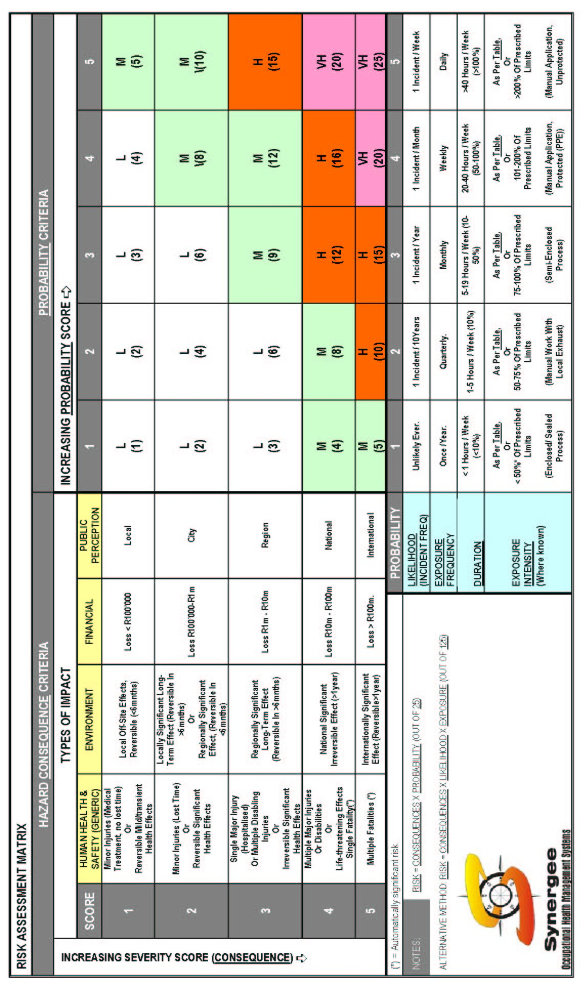
Table 3: Scoring “Exposure” Intensity: Guidelines for Physical & Environmental Hazards
This information is used in the preceding table, to determine the intensity of exposure to the following Hazardous Agents.
HAZARD | 1 (Low)  + | 2 (Med)  ++ | 3 (High)  +++ | 4 (V-High)  ++++ | 5 (Extreme)  ++++ | Aggravating Factors
Noise | 75-85dB(A) (TWA – 8hrs) | 85 – 90dB(A) (TWA – 8hrs) | 91 – 95dB(A) (TWA – 8hrs) | 96 – 105dB(A) (TWA – 8hrs) | over 105dB(A) (TWA – 8hrs) | Percussion / Impact Noise
Heat | WBGT index exceeds 25. | WBGT index exceeds 27.5. | WBGT index exceeds 30.0. | WBGT index exceeds 32.5. | WBGT index exceeds 35.0. | Heavy work rates
Cold | Dry bulb temp +5 to 0ºC  (OEL = no limit) | Dry bulb temp 0 to –18ºC  (OEL = no limit) | Dry bulb temp –18 to –34ºC  (OEL = 50 min / hour) | Dry bulb temp –34 to –57ºC  (OEL = 60min / day) | Dry bulb temp < –57ºC  (OEL = 5min / 8hr period) | Wetness, wind, lack of cover.
Glare | Mild degree of glare  Eg. Reflected light from computer screen, indoors. | Mod degree of glare  Eg. Reflected bright sunlight, outside. | Mod-high degree of glare  Eg. Reflected bright sunlight off sea. | Severe degree of glare  Eg. Furnaces, welding |  | UV and/or infrared light
Vibration  (Segmental) | 50-75% of prescribed limits  Low amplitude, high frequency (>2kHz)  Eg. Hand-held electric percussion drill. | 75-100% of prescribed limits  Moderate amplitude, moderate frequency (1-2kHz)  Eg. | 101-200% of prescribed limits  High amplitude, low frequency (<1kHz)  Eg. Pneumatic drilling machine. | >200% of prescribed limits |  | Cold exposure.
Vibration  (Whole body) | 50-75% of prescribed limits  Low amplitude, high frequency (>2kHz)  Eg. Electric motors. | 75-100% of prescribed limits  Moderate amplitude, moderate frequency (1-2kHz)  Eg. Diesel engines. | 101-200% of prescribed limits  High amplitude, low frequency (<1kHz)  Eg. Vibrating platform on a rig. | >200% of prescribed limits
Radiation  (Ionising) | 25-50% of prescribed limits | 50-75% of prescribed limits | 75-100% of prescribed limits | 101-200% of prescribed limits | >200% of prescribed limits
Radiation  (Non-ionising) | 25-50% of prescribed limits (TLV)* | 50-75% of prescribed limits (TLV)* | 75-100% of prescribed limits (TLV)* | 101-200% of prescribed limits (TLV)* | >200% of prescribed limits (TLV)*
Ergonomic | Low demand  (Work rate/rest periods) | Moderate demand  (Work rate/rest periods) | Moderate – High demand  (Work rate/rest periods) | High demand  (Work rate/rest periods) | Extreme demand  (Work rate/rest periods)
*: The “TLV” (Threshold Limit Value) is quoted here because these limits are published by the American Conference of Governmental Hygienists (ACGH), and are easily available in the ACGIH publications. South African Standards (“OEL’s”) are to be used as these are gazetted.

Notes to “Intensity”:
This information is fairly technical in nature. It is usually measured by experts and presented to the company in reports. For the purposes of the OREPs, the scores are allocated according to these reported measurements. Hence they can only be estimated if measurements have been taken, or if estimates based on comparisons with other areas (where measurements were taken) can be made.
Generally, this information is expressed relative to the statutory OEL’s (when available). Note – OEL = Occupational Exposure Limit. When no local OEL is available, an easily accessible standard, such as the ACGIH standard can be used.
The presence of “aggravating factors” is a warning to the scorer to choose a value higher than the one indicated by the column.

THE APPENDICES
The Appendices include the following:
- Sample OREP: 1-column
- Sample OREP: 3-column.

Appendix 1: Illustration of an OREP, with 1-column Risk Reference.
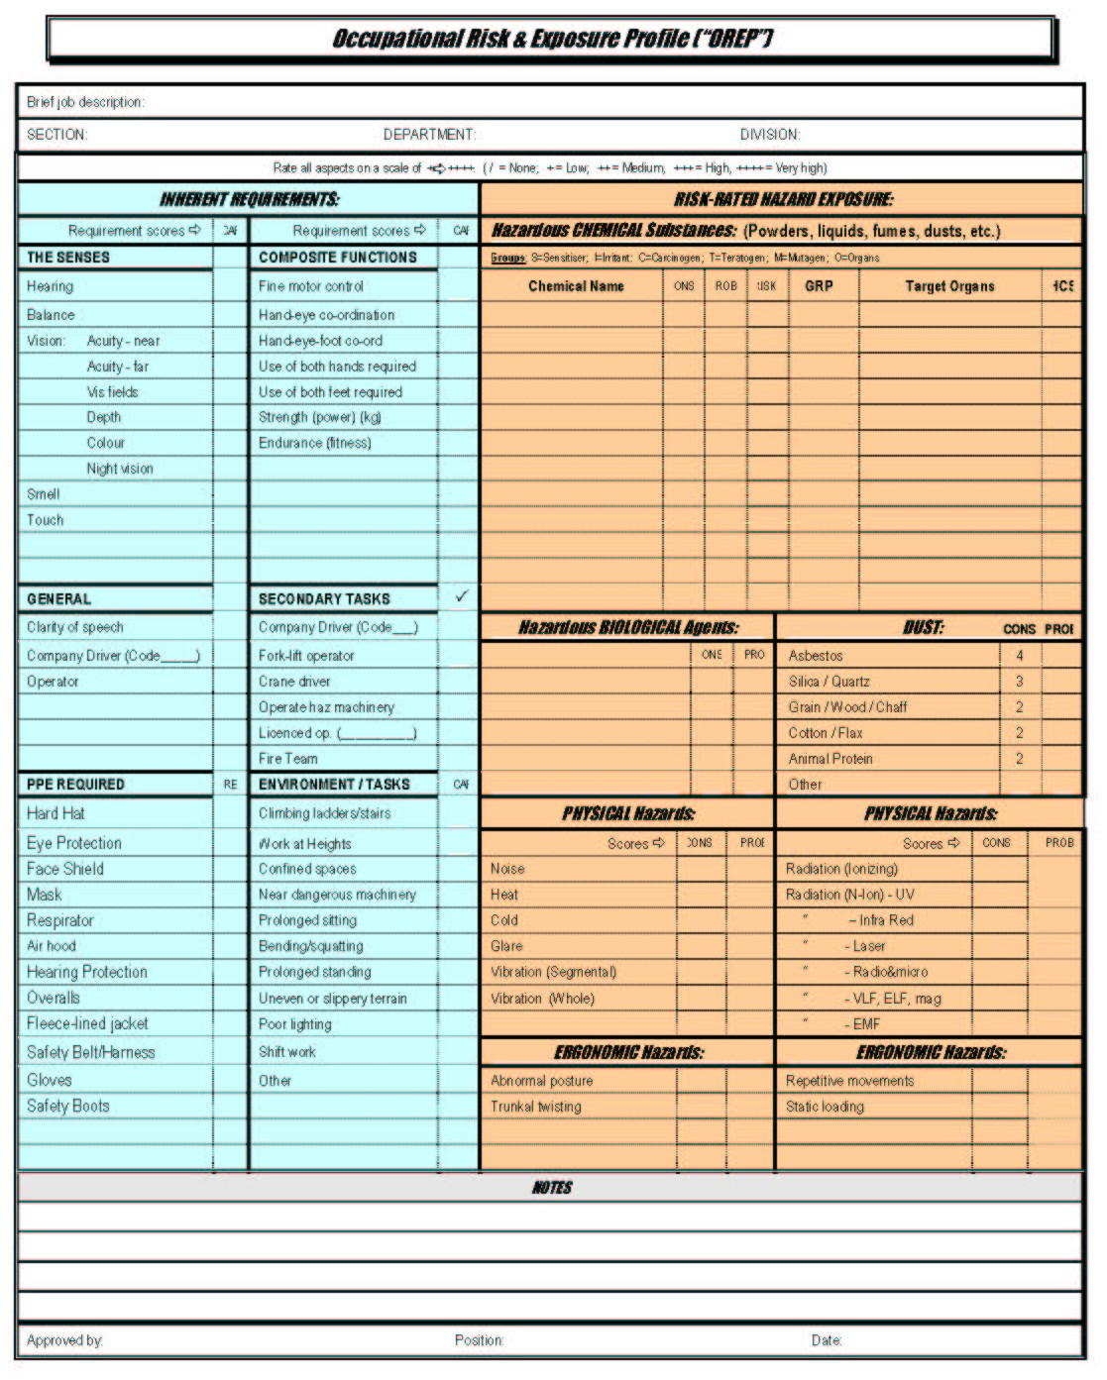
Record ““Consequence” Scores in the 1st Column.
Record “Probability” or “Exposure” Scores in the 2nd Column.
Record “Risk Index” Scores in the 3rd Column. These are the result of
Consequence x Probability.
Record “Capability Requirement” Standards in the 1st Columns.
These are taken from Table 1.
Record the list of chemicals here.
The list is derived from interviews, inspections, or from the HCS Profile.

The characteristics of the chemicals are taken from the HCS Profile.

Record the list of hazardous biological agents here, as for the chemicals above.
Record “Consequence” & “Probability” Scores as above.

Appendix 2: Illustration of an OREP, with 3-column Risk Reference.
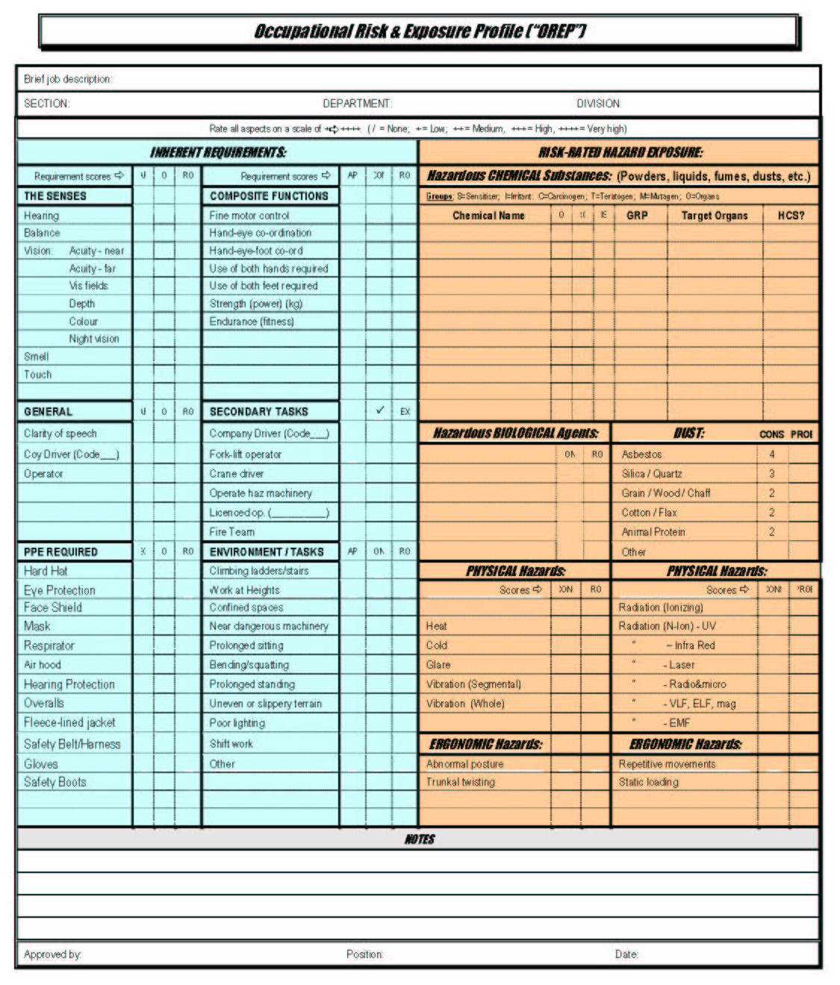
Record ““Consequence” Scores in the 1st Column.
Record “Probability” or “Exposure” Scores in the 2nd Column.
Record “Risk Index” Scores in the 3rd Column. These are the result of
Consequence x Probability.
Record “Capability Requirement” Standards in the 1st Columns.
These are taken from Table 1.
Record “Consequence” Scores in the 2nd Columns.
Record “Probability” Scores in the 3rd Columns.
Record the list of chemicals here.
The list is derived from interviews, inspections, or from the HCS Profile.

The characteristics of the chemicals are taken from the HCS Profile.

Record the list of hazardous biological agents here, as for the chemicals above.
Record “Consequence” & “Probability” Scores as above.

